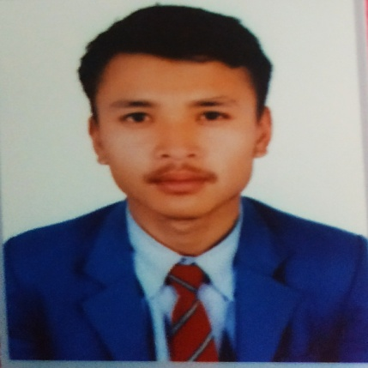

**Digital Marketing**

**Affiliated by Google**

**Web Designing**

**Aptech Institution ( 3 months)**

* **Participate in many voluntary works and rally organised by Nepal Scout.**
* **Became first in football tournament oragnised by Godawari Municipality.**
* **Certified with certificate of excellence from HOD of Mathematics of Laligurans English Secondary School.**

*I had great time in my college as I was loved by all my spouse and teachers because I was very much extrovert person and I always secured Outstanding marks in exam .*

**DAV College**

**National Examination Board ( 2017-2019 A.D. ) - B+**

*I had experienced plethora of things and lots of knowledge from my school. The most important things that I have learn from school is discipline . I was counted as most intelligent student as I secured excellent result especially in math and also known as math king in school. By seeing my great performance in mathematics , I was certified by certificate of excellence .*

**QUALIFICATION AND EXTRA CURRICULUM ACTIVITIES**

**I am eminent , extrovert and hardworing fresher student. I had achieved many rewards and secured excellence result in academies.**

**Date of birth: 12November 2001**

**Nationality: Nepali**

**Father’s name: Shree Gopal Maharjan**

**Mother’s name: Nanda Devi Maharjan**

**Languages: Newari, Nepali, Hindi, English**

**Religion: Hinduism**

**Laligurans English Secondary School**

**Secondary Education Examination ( 2016 A.D. ) - A+**

**EDUCATION**

**Reading**

**Music**

**🖳**

**Programming**

**🎧**

**🖹**

**Travel**

**www.mitchlucker369.com**

**Badegaun, Lalitpur, Nepal**

**+977-9869105302**

**maharjansanish204@gmail.com**

**🖂**

**🌏**

**🕿**🕿

**🏠**

**✈**

**HOBBIES**

**CONTACT**

**PROFILE**

**SANISH MAHARJAN**

**CURRICULUM VITAE**